COMPLIER DESIGN   
 (19CSE401)  
 LAB – 1

NAME: N SANJANA  
ROLL N0: CH.EN.U4CES22138

1. AIM: To Program to Identify Vowels and Consonants  
   ALGORITHM:

* Start the program.
* Read each character from input.
* If character is a vowel (a, e, i, o, u case-insensitive):  
   → Print "Vowel".
* Else if character is an alphabet letter:  
   → Print "Consonant".
* Ignore other characters (digits, symbols, spaces).
* Repeat until end of input.
* End  
  CODE:   
  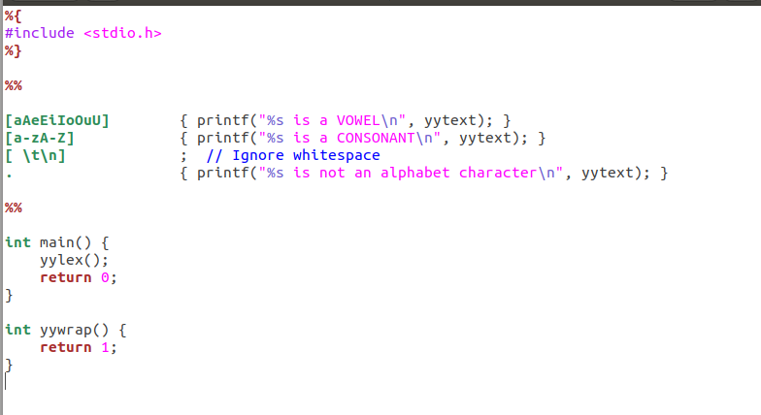RESULT:  
  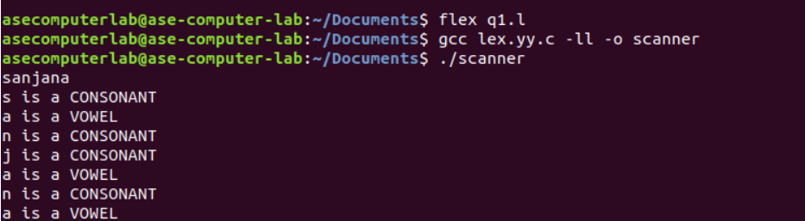

1. AIM: To Program to Count Lines, Words, and Characters  
   ALGORITHM:

* Start the program.
* Initialize counters: line = 0, word = 0, char = 0.
* For each input token:
* If newline (\n) → increment line.
* If word ([a-zA-Z0-9]+) → increment word.
* For every character → increment char.
* Continue until end of file.
* Print line, word, and character counts.
* End.  
  CODE:  
  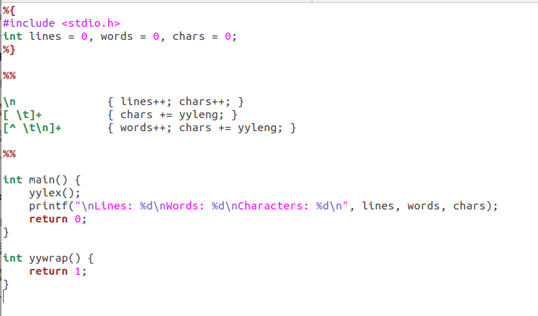RESULT:  
  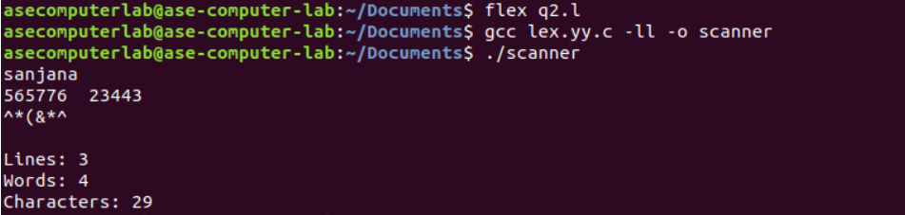

1. AIM: To Recognize Integers and Floating-Point Numbers  
   ALGORITHM:

* Start the program.
* Read input tokens one by one.
* If token matches integer pattern ([0-9]+) → print "Integer".
* If token matches floating-point pattern ([0-9]+\.[0-9]+) → print "Floating-point number".
* Ignore other tokens.
* Repeat until end of input.
* End.

CODE:  
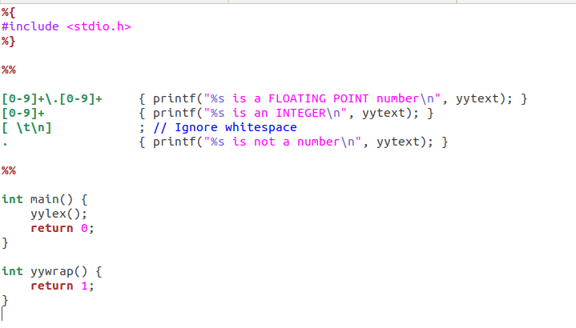RESULT:  
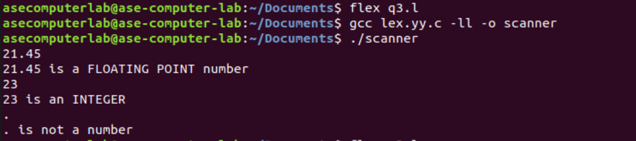

1. AIM: To Program to Recognize C Keywords  
   ALGORITHM:

* Start the program.
* Read each word/token from input.
* If the token matches a C keyword  
   (e.g., int, float, if, else, while, etc.) → print "Keyword".
* Else, ignore or label as "Not a keyword".
* Repeat until end of input.
* End.

CODE:  
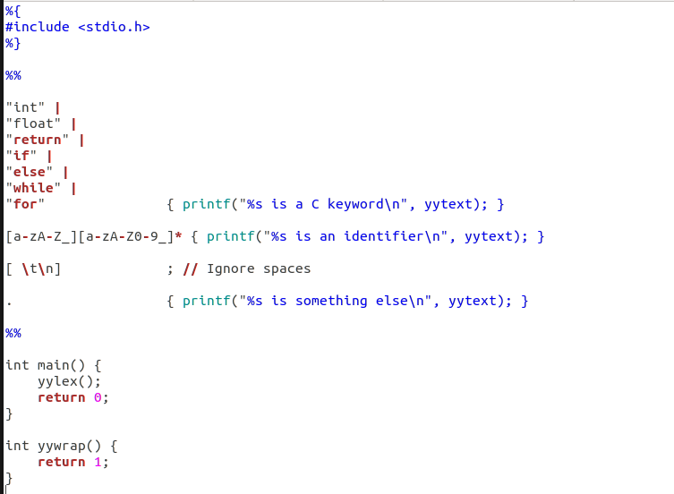RESULT:  
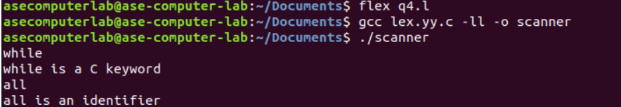

1. AIM: To Program to Recognize Operators.  
   ALGORITHM:

* Start the program.
* Read each character or token from input.
* If it matches an operator  
   (e.g., +, -, \*, /, %, =, ==, <=, >=, &&, ||, etc.)  
   → print "Operator".
* Ignore other characters.
* Repeat until end of input.
* End.  
  CODE:  
  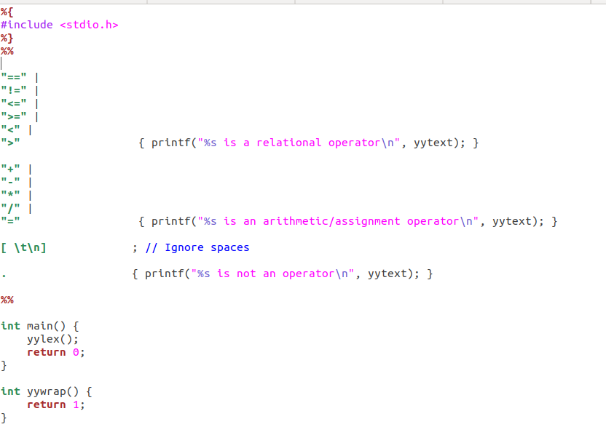RESULT:  
  